**Re Assure API Internal Testing-Estimation Approval API**Applicable for Acko only)***

1. Please change “Entity” to “Claim Approval” from the confirmation message of successful claim approval.

{

    "status": "Success",

   "message": "Entity has been updated successfully.",

    "data": null

}

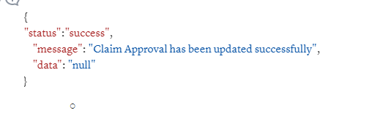

2. Claim status should not get update in case of CPP but this is happening.  
  
{

"aiz_claim_number": "06384113",

"approval_status": "on hold"

}

Message:  
 *{*

*"status": "Success",*

*"message": "Entity has been updated successfully.",*

*"data": null*

*}*

**Re Assure API Internal Testing-** **Escalated Cases API**

1. Please change “Entity” to “Escalation Status” from the confirmation message of successful escalation.  
     
   {

"status": "Success",

"message": "Entity has been updated successfully.",

"data": null

}